### INTELLIGENT CUSTOMER HELP DESK WITH SMART DOCUMENT UNDERSTANDING

By: **SWAGATIKA GIRI**

Artificial Intelligence Developer Intern

(AI 6)

***INTRODUCTION***

**1.1 Overview**

Objective is to make an Intelligent Customer Help Desk Service with Smart Document Understanding.

A ChatBot is Artificial Intelligence (AI) software that can simulate a conversation (or a chat) with a user in natural language through messaging applications, websites etc.

ChatBots can help people quickly find answers they need to critical questions.

A working example of a web app that utilizes multiple Watson services to create a better customer care experience.

Using the Watson Discovery Smart Document Understanding (SDU) feature, we will enhance the Discovery model so that queries will be better focused to only search the most relevant information found in a typical owner's manual.

Using Watson Assistant, we will use a standard customer care dialog to handle a typical conversation between a customer and a company representative. When a customer question involves operation of a product, the Assistant dialog will communicate with the Discovery service using a webhook.

The webhook will be created by defining a web action using IBM Cloud Functions.

**SDU:**

Smart Document Understanding (SDU) trains Watson Discovery to extract custom fields in our documents. Customizing how your documents are indexed into Discovery will improve the answers returned from queries.

With SDU, you annotate fields within your documents to train custom conversion models. As you annotate, Watson is learning and will start predicting annotations. SDU models can also be exported and used on other collections.

**1.2 Purpose**

I have made a Dog training Bot. Purpose is to help growing any Dog website; dog trainers or any other dog service provider.

In my code pattern, if the customer question is about the training of dog, we will use the webhook feature of Watson Assistant to pass the question onto our Watson Discovery Service, which has been pre-loaded with training book. So now, instead of “Would you like to speak to a customer representative?” we can return relevant sections of the book to help solve our customers’ problems.

To take it a step further, we will use the Smart Document Understanding feature of Watson Discovery to train it on what text in the book is important and what is not. This will improve the answers returned from the queries.

***LITERATURE SURVEY***

**2.1 Existing problem**

Dog training has become an ever-evolving profession, updating and creating new training techniques and behavior modification protocols as new data becomes available

For beginner trainers, the sheer volume of information to digest and the diversity of skills to master could be quite overwhelming. Dog trainers need to know how to work with dogs when they stop taking food or when another reinforces may be more.

For helping dog parents there are many websites from which the customer can learn. But this could be time consuming so, for enhancing user experience and help trainers to grow their services a ChatBot can help.

**2.2 Proposed Solution**

For saving time and energy and to help in growing of pet related services a ChatBot is built that can be deployed in any website and help the community.

***FLOWCHART***

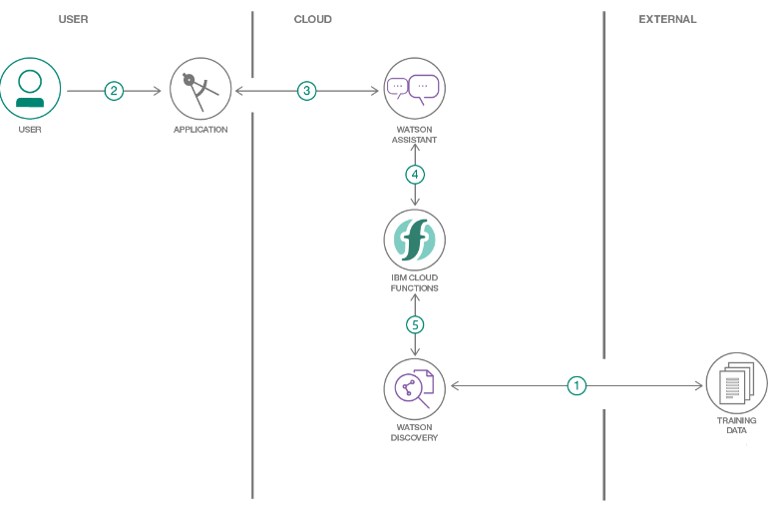

***RESULT***

Anyone can access the Bot with this URL: <https://node-red-sg0.eu-gb.mybluemix.net/ui/#!/0?socketid=7ZNY6vfRUQgJiKu0AAAX>

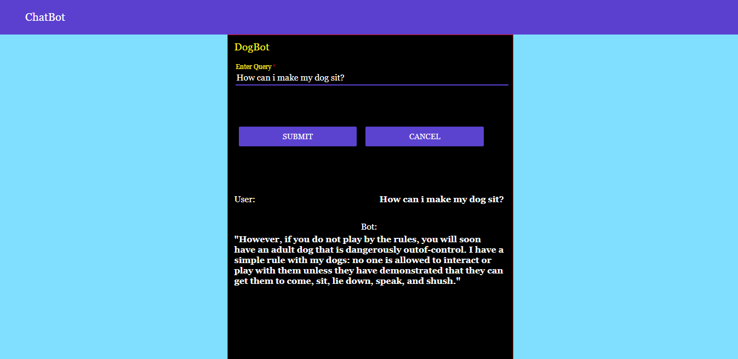



***TESTIMONIAL VIDEO:***   
<https://youtu.be/I9AisGI2bRI>

***DEMO VIDEO:***

<https://youtu.be/Mz1yvEZDjUQ>

***ADVANTAGES AND DISADVANTAGES***

**Advantages:**

**1. Gather Customer Insights**

ChatBots can help you gather precious data from your customers by interacting with them. This includes getting insights about their activities, preferences, problems, and more.

Additionally, you can find out what their most common problems are and take steps to solve them. When you’ 2. Increase Sales re able to resolve their issues with ease, they’ll be more likely to stick with your brand.

You can use ChatBots to offer immediate support to your potential customers. When their issues are resolved instantly, they may take your desired action as well. This could mean an increase in your lead generation, which can translate into more sales.

Additionally, you can use ChatBots to market your latest products and send out updates to your customers. It’s a more personalized mode of marketing as the promotion or update is sent directly to the customer. This can improve your chances of generating sales as well.

**2. Available 24/7**

One of the biggest advantages of ChatBots is that they’re available for your customers around the clock. Additionally, they answer promptly to every query that’s presented to them. This ensures that your customers will always find solutions to their problems, be it day or night.

**3. Save Money**

If you don’t use ChatBots, you need to pay your customer support team’s wages every month. This is a recurring expense that can be big if you have a large staff to respond to customers quickly. As your business grows, this expense will only increase.

**4. Improve Customer Satisfaction**

The conversations that your customers have with your business matter a lot. They help shape the opinions consumers have about your business.

**Disadvantages:**

1. Lack Emotions
2. Require Maintenance
3. Made to handle first-level questions.

***CONCLUSION***

A working example of a web app that utilizes multiple Watson services to create a better customer care experience is ready.

Using the Watson Discovery Smart Document Understanding (SDU) feature, we will enhance the Discovery model so that queries will be better focused to only search the most relevant information found in a typical owner's manual.

Using Watson Assistant, we will use a standard customer care dialog to handle a typical conversation between a customer and a company representative. When a customer question involves operation of a product, the Assistant dialog will communicate with the Discovery service using a webhook.

The webhook will be created by defining a web action using IBM Cloud Functions.

The webhook will communicate with an IBM Cloud Functions web action, which is connected to the Watson Discovery service.

***FUTURE SCOPES***

In future, the Watson assistant will be deployed to different third party applications like Facebook, Slack, and Telegram etc.

***BIBLIOGRAPHY***

* <https://github.com/IBM/watson-discovery-sdu-with-assistant>
* <https://developer.ibm.com/patterns/enhance-customer-help-desk-with-smart-document-understanding/>
* <https://developer.ibm.com/tutorials/how-to-create-a-node-red-starter-application/>
* <https://cloud.ibm.com/docs/openwhisk?topic=cloud-functions-getting-started>
* <https://developer.ibm.com/articles/introduction-watson-discovery/>